Single-Photoelectron Calibrated Absolute Light Yield of Cs₃Cu₂I₅ Scintillator Grown by Room-Temperature Vacuum Solvent Evaporation

Jihwan Boo¹, Seungho Song², Yeong-Seo Gwon¹, Beomjun Park³, Jung-Yeol Yeom^{2,4}, Geehyun Kim^{5*}

¹Department of Energy Systems Engineering, Seoul National University, Seoul, Republic of Korea
²Dept. of Bioengineering, Korea University, Seoul 02841, Republic of Korea
³Nuclear Research Institute for Future Technology and Policy (NIFTEP), Seoul National University, Seoul 08826, Republic of Korea
⁴School of Biomedical Engineering, Korea University, Seoul 02841, Republic of Korea
⁵Department of Nuclear Engineering, Seoul National University, Seoul, Republic of Korea
Corresponding Author Email: gk.rs@snu.ac.kr

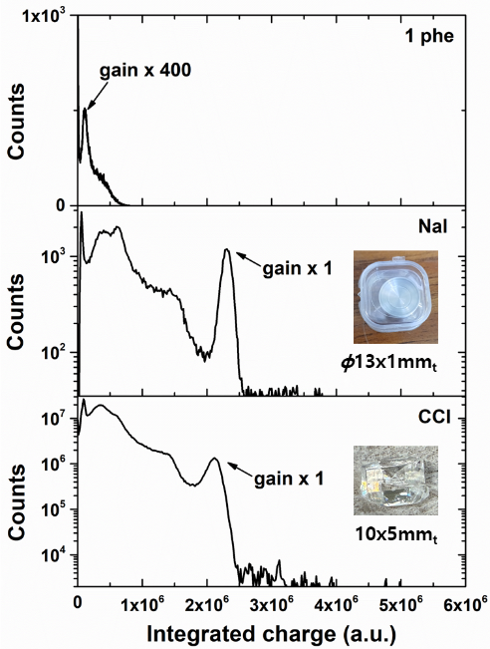
Lead-free zero-dimensional halide perovskite Cs₃Cu₂I₅ (CCI) has recently emerged as a promising scintillator for gamma-ray spectroscopy, demonstrating excellent crystallinity and high spectrometric performance, including an energy resolution of 3.3% at 662 keV and a high reported light yield in single-crystal form [1]. Since relative light-yield values depend on the reference scintillator and on geometry-dependent light collection, an independent absolute light-yield quantification is essential.
Figure 1. SPE-based absolute light-yield quantification. Integrated-charge distributions for NaI and CCI under ¹³⁷Cs irradiation, together with the single-photoelectron (1 phe) reference spectrum used to convert photopeak charge to photoelectrons and then to photons/MeV.
In this study, we quantify the absolute light yield of a CCI single-crystal scintillator grown by a room-temperature vacuum solvent-evaporation technique (SVET) [2] using a single-photoelectron (SPE) calibration method. We benchmark the result against a thin 1-mm NaI(Tl) scintillator. For both the pulsed-LED SPE calibration and ¹³⁷Cs (662 keV) γ-ray spectroscopy, PMT anode waveforms were recorded and charge-integrated using a CAEN DT5730 digitizer with trigger-synchronized acquisition and time-window filtering to suppress random coincidences, following the procedure reported in our previous work [3]. Using this approach, the absolute light yield of CCI was measured to be 42,100±200 photons/MeV, while the 1-mm NaI(Tl) reference yielded 40,600±200 photons/MeV. The NaI(Tl) result agrees well with the widely cited literature value of approximately 40,000 photons/MeV, supporting the validity of the calibration. These results indicate that the tested CCI scintillator can deliver an absolute light yield comparable to that of NaI(Tl) under 662 keV gamma irradiation, highlighting its potential for compact, high-performance gamma-ray detection. Ongoing work includes repeating the SPE calibration to further reduce systematic uncertainty and extending the comparison to additional energies and operating conditions.

1. L. Stand, D. Rutstrom, M. Koschan, M.H. Du, C. Melcher, et al. "Crystal growth and scintillation properties of pure and Tl-doped Cs₃Cu₂I₅." Nucl. Instrum. Methods Phys. Res. A, 991 164963 (2021).
2. J. Seo, S. Song, M. Park, J. Byun, B. Park, et al. “High Performance Gamma-ray Spectrometer Based on Cs₃Cu₂I₅ single crystal grown by Room-Temperature Vacuum Solvent-evaporation Method,” Journal of Alloys and Compounds, 1027, 180583 (2025).
3. J. Boo, N. Kim, G. Kim, “Digitizer-based single-photoelectron detection approach for the light yield measurement of inorganic scintillators,” J. Radiat. Prot. Res. (In Press). https://doi.org/10.14407/jrpr.2025.00115.

This work was supported by the National Research Foundation of Korea (NRF) grant funded by the Korea government (Ministry of Science and ICT) (No. 2022M2D2A1A02063826).

