Characterization of a Phoswich Detector Using CLYC and Plastic Scintillators

HyeoungWoo Park¹, Dong Woo Jeong², Young SooYoon³

¹Central Research Institute, Korea Hydro & Nuclear Power Co., Ltd., Daejeon Korea
²Department of Physics, Kyungpook National University, Daegu, Korea
³Korea Research Institute of Standards and Science, Daejeon, Korea

Corresponding Author Email: hyeoungwoopark@gmail.com and ysy@kriss.re.kr

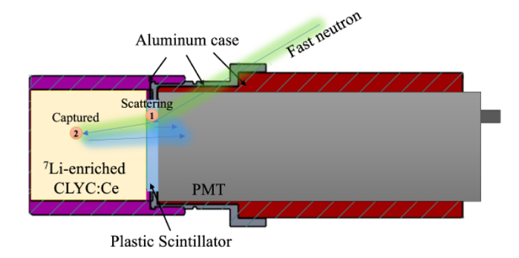
A phoswich-type detector composed of CLYC and plastic scintillators is designed for radiation monitoring in nuclear power plants and for fast neutron measurements. The phoswich configuration combines the advantages of each scintillator. The plastic scintillator provides fast timing performance suitable for high counting rates and good timing resolution. In contrast, the CLYC scintillator offers a slow decay time but enables full-energy gamma spectroscopy and fast neutron capture detection [1]. Both scintillators allow neutron–gamma separation using pulse shape discrimination. In particular, the phoswich coupling of the two scintillators generates characteristic signals from fast neutron scattering in the plastic scintillator followed by neutron capture in CLYC, as illustrated in the figure. These combined signals provide additional analytical advantages for neutron event identification.
In this study, the detector response was first evaluated using Geant4 simulations under monoenergetic neutron fields. A prototype detector was then fabricated and experimentally characterized. Energy calibration was performed using gamma-ray sources. Fast neutron characterization was conducted at a monoenergetic neutron reference field at the Korea Research Institute of Standards and Science [2]. Individual signals from the CLYC and plastic scintillators were analyzed, together with coincident neutron events identified using pulse shape discrimination. The results demonstrate the potential of the phoswich detector for simultaneous gamma-ray and neutron monitoring. Furthermore, the compact size and low power consumption of the phoswich detector make it suitable for deployment in weight- and power-constrained environments, such as radiation monitoring using portable radiation detector systems and robotic platforms. The detector is expected to be applied to digital twin–based radiation monitoring systems in future nuclear applications.
Design of a phoswich detector composed of a plastic scintillator and a CLYC scintillator, showing characteristic signals from fast neutron scattering and capture events.

1. Soundara-Pandian, Lakshmi, et al., "Characterization of large volume CLYC scintillators for nuclear security applications," IEEE transactions on Nuclear Science, 64, 7, 1744-1748 (2017).

2. Kang, Sinchul, et al., "Fluence measurement of monoenergetic neutrons from D (d, n) and T (d, n) reactions at the KRISS," Radiation Measurements 177, 107234 (2024).

Acknowledgments
This research was supported by the Korea Research Institute of Standards and Science (KRISS- GP2025-0008-01).

