Growth and scintillation properties of Mo co-doped Ce:Gd₃(Ga,Al)₅O₁₂ single crystals

Kyoung Jin Kim^{1,2}, Kei Kamada^{1,2}, Masao Yoshino^{1,3}, Yasuhiro Shoji³, Vladimir Kochurikhin³, Akira Yoshikawa^{1,2,3}

¹New Industry Creation Hatchery Center (NICHe), Tohoku University, Sendai, Japan
²C&A Corporation, Sendai, Japan
³Institute for Materials Research (IMR), Tohoku University, Sendai, Japan
Corresponding Author Email: kyoung.jin.kim.c4@tohoku.ac.jp

Many kinds of scintillator materials, such as Ce:Y₃Al₅O₁₂ (Ce:YAG), Ce:Lu₃Al₅O₁₂, and Pr:Lu₃Al₅O₁₂, were developed. Ce:Gd₃(Al, Ga)₅O₁₂ is a newly developed single crystal scintillator [1]. The Ce-doped Gd₃(Ga,Al)₅O₁₂ (Ce:GAGG) is one of the most attractive scintillator materials from the point of view of light output, decay time, energy resolution, density and absence of intrinsic radioactivity. Scintillator crystals coupled with photo detectors have been widely used in high-energy radiation imaging applications such as gamma cameras, positron emission tomography (PET), and others. For these applications, the scintillating properties should include good energy resolution, high stopping power, high light yield, and fast decay time. Numerous studies have been conducted on the effects of rare earth doping and/or co-doping with various cations in GAGG crystal structure, multicomponent garnet based on YAG crystal with an admixture of Ga and Gd, to improve its properties. It was reported that the scintillation properties of Ce:GAGG depend on the ratio of Ga to Al [2].
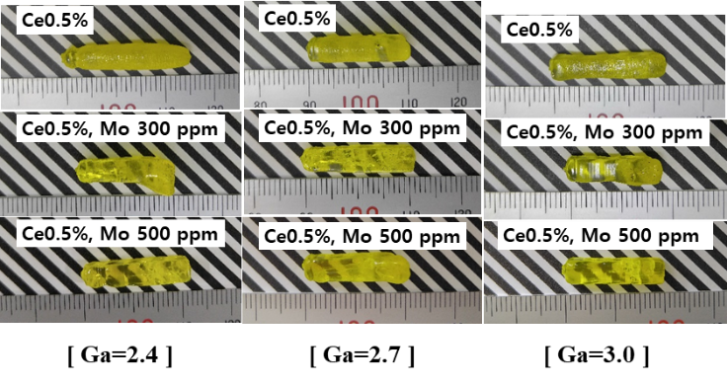
In this study, the performance of Mo co-doped Ce0.5%:Gd₃Ga_{x}Al_{5−x}O₁₂ single crystal scintillators with different ratio of Al and Ga (x=2.4, 2.7, 3.0) was investigated. All these crystals were prepared by the micro-pulling (μ-PD) down method. We have investigated the relationship between the eﬀects of reducing Ga content in Ce:GAGG and the eﬀects of co-doping with Mo ion in Ce:GAGG. The scintillation properties of the grown crystals such as light yield and decay time were evaluated. The energy spectra of non co-doped and Mo co-doped Ce:GAGG, excited by ¹³⁷Cs, are measured at room temperature using a Photomultiplier Tube (PMT). Scintillation decay curves were observed by using digital oscilloscope TDS3052B under the excitation by ¹³⁷Cs radioisotope (662 keV).
Figure 1. Photos of the grown Mo co-doped and non co-doped Ce:Gd₃Ga_{x}Al_{5−x}O₁₂ crystals.
Light output was increased in a sample with the small amount of Mo concentration and maximum light output of 112% compared to the non co-doped Ce:GAGG was obtained in the Mo 300 ppm co-doped crystal with x=3.0. The scintillation decay was also accelerated to 57.2 ns by Mo 500 ppm co-doping with x=3.0. Details of changes in scintillation properties with Mo co-doping will be reported at the conference.

[1] K. Kamada, A. Yoshikawa, et al., “Composition Engineering in Cerium-Doped (Lu,Gd)₃(Ga,Al)₅O₁₂ Single-Crystal Scintillators,” Cryst. Growth and Des., 11, 4484–4490 (2011).
[2] K. Kamada, A. Yoshikawa, et al., “Cz grown 2-in. size Ce:Gd₃(Al,Ga)₅O₁₂ single crystal; relationship between Al, Ga site occupancy and scintillation properties,” Opt. Mater., 36, 1942-1945 (2014).

