2 inch diameter growth of Ce,Mg :Y₃(Ga,Al)₅O₁₂ scintillator and prototyping of fine-pitch scintillator arrays for pulse-counting CT

Kei Kamada^{1,2} Yasuhiro Shoji, Hisato Suezumi¹, Masao Yoshino^{1,2}, Liudmila Gushchina², Kenji Shimazoe³, Kyohei Sakamoto⁴, Akira Yoshikawa^{1,2}

¹ Tohoku Univ., Sendai, Japan, ² C&A Corp. , Sendai, Japan, ³The University of Tokyo, Bunkyo-ku, Tokyo, Japan, ⁴Diatrend Corporation, Osaka, Japan

Corresponding Author Email: kei.kamada.c6@tohoku.ac.jp

The development of scintillator-based pulse-counting X-ray computed tomography (PCCT) using the garnet scintillators has considerably been focused on in recent years.[1,2]. In the case of Mg,Ce:Gd₃Ga₃Al₂O₁₂, the Gd-Kα escape peak of ~50 keV makes energy discrimination in this energy region of PCCT difficult. The reduction in light yield and the deterioration of energy resolution due to Mg co-doping are also issues. On the other hand, Mg,Ce: Y₃₍Ga,Al)₅O₁₂ (YAGG) grown by micro pulling down method was reported with a high light yield of ~36000 photon/MeV and fast decay time of ~20 ns[3]. Since YAGG does not contain Gd and Y-Kα scape peak is as low as ~20 keV, it has no adverse effects on PCCT. Mg²⁺ co-doping enhance the light yield and accelerate the decay time [3] and Mg,Ce:YAGG is promising scintillator for PCCT. In this research large size Mg and Ce co-doped YAGG single crystals were grown by the Cz method. A prototype of a fine-pitch scintillator array was integrated with a SiPM array of an identical pitch for performance evaluation.
Stoichiometric mixtures of 4N MgCO₃, CeO₂, Y₂O₃, β-Ga₂O₃ and α-Al₂O₃ powders were used as starting material. Nominally, Y³⁺ site was substituted by Ce³⁺ and Mg²⁺ according to the formula of (Ce_{x}Mg_{y}Gd_{1-x-y})₃(Al,Ga)₅O_{12.} Single crystals were grown by means of the Cz method using an RF heating system. The rotation rate was 4–12 rpm and the growth rate was 1.0 mm/h. Crystals were grown from a 110 mm diameter Ir crucible under N₂ with 1.5% O₂ atmosphere to prevent evaporation of gallium oxide. The seed crystal was a [100] oriented YAG crystal. A 2-inch diameter Mg,Ce:YAGG single crystal was successfully grown (Fig.1). During crystal growth, an Ir metallic film originating from the Ir crucible precipitated on the melt surface, which interfered with the automatic diameter control and resulted in the adhesion of Ir metal to the crystal surface. Furthermore, fine-pitch scintillator arrays with a pixel size of 200 × 200 × 1000 μm and a white reflector thickness of 50 μm were fabricated from the grown crystals. Details regarding crystal growth, scintillation properties, and the performance of the detector integrated with a SiPM array with 200 μm pixel will be reported in the presentation
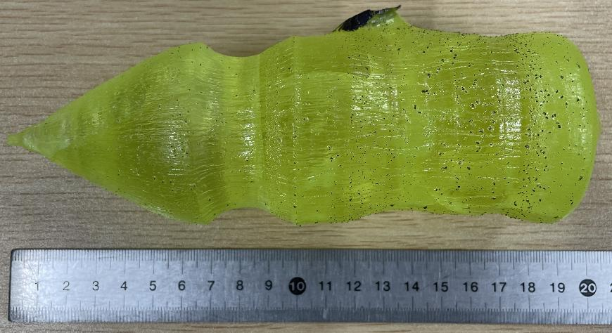Fig. 1 2-inch diameter Mg,Ce:YAGG single crystal grown by the Cz method
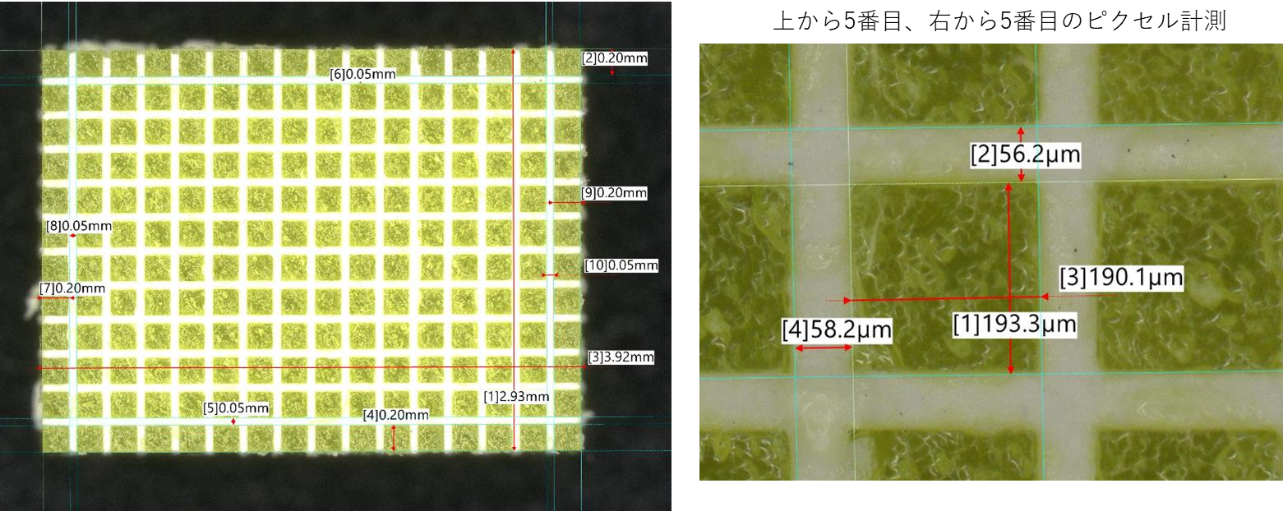
Fig.2 Fine-pitch scintillator arrays with a pixel size of 200 × 200 × 1000 μm and a white reflector thickness of 50 μm

[1] K. Shimazoe, …K.Kamada. et al. Commun Eng 3 (2024)167.
[2].K.Kamada., et al, Opt. Mater. 36 (2014)1942
[3] K.Kamada, et al, IOP Conf. Ser.: Mater. Sci. Eng. 169 (2017) 012013

Acknowledgments should appear near the bottom of the page.

This is the last possible line of text to leave a 2 cm bottom margin. No page number.

