Tb³⁺-Doped Alkali Boro-Phosphate Glasses as Promising Scintillators for X-Ray Imaging Applications

N. Kiwsakunkran^{1,2*}, N. Chanthima^{1,2}, P. Kidkhunthod³, A. Angnanon^{4,5}, N. Intachai⁴, S. Kothan⁴,
H.J. Kim⁶, J. Kaewkhao^{1,2}

¹Physics Program, Faculty of Science and Technology, Nakhon Pathom Rajabhat University, Nakhon Pathom, 73000, Thailand
²Center of Excellence in Glass Technology and Materials science (CEGM), Nakhon Pathom Rajabhat University, Nakhon Pathom, 73000, Thailand
³Synchrotron Light Research Institute, Nakhon Ratchasima, 30000, Thailand
⁴Center of Radiation Research and Medical Imaging, Department of Radiologic Technology, Faculty of Associated Medical Sciences, Chiang Mai University, Chiang Mai,
50200, Thailand
⁵ Office of Research Administration, Chiang Mai University, Chiang Mai, 50200, Thailand
⁶Department of Physics, Kyungpook National University, Daegu, 41566, Republic of Korea

Corresponding Author Email: nuchjaree.kiw@hotmail.com

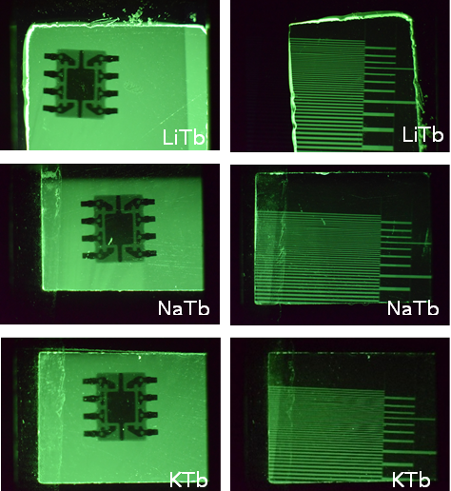
Tb³⁺-activated alkali boro-phosphate glasses were synthesized via the melt-quenching method and systematically evaluated as scintillator materials for medical X-ray imaging and radiation detector applications. The optical, photoluminescence (PL), decay dynamics, and X-ray-induced luminescence (RL) properties were correlated with local structural features probed by X-ray absorption spectroscopy (XANES/EXAFS). Under optical excitation, the glasses exhibit intense green emission centered at 547 nm, originating from the ⁵D₄ → ⁷F₅ transition of Tb³⁺ ions. Efficient energy transfer from Gd³⁺ to Tb³⁺ was confirmed through excitation spectra and lifetime analysis, with transfer efficiencies reaching 76%. Structural analysis reveals stable trivalent Tb³⁺ ions coordinated by oxygen in a distorted environment, which plays a crucial role in enhancing radiative transitions. Upon X-ray excitation (50 kV, 30mA), all samples demonstrate strong radioluminescence with emission bands well matched to the spectral sensitivity of common photodetectors used in medical imaging systems. The glass containing 2.0 mol% Tb₂O₃ achieves an integral scintillation efficiency more than 50% relative to commercial BGO scintillators. Moreover, X-ray imaging tests using a standard line-pair confirm a spatial resolution of up to 10 lpmm⁻¹, demonstrating the capability of these glasses for high-resolution imaging. These findings highlight Tb³⁺-doped alkali boro-phosphate glasses as promising, cost-effective scintillator candidates for medical X-ray detectors, offering competitive scintillation efficiency, tunable structural properties, and excellent imaging performance.
X-ray images of an encapsulated chip and a standard line-pair card of LiTb, NaTb and KTb glasses

