Sm³⁺-doped Sodium Yttrium Borate Glass for X-ray Imaging Scintillator

N. Wantana^{1,2}, E. Kaewnuam^{3,*}, F. Khrongchaiyaphum^{1,2}, Y. Ruangtaweep^{1,2}, T. Keawmon^{1,2},
P. Pakawanit⁴, C. Phoovasawat⁴, N. Intachai⁵, S. Kothan⁵, H.J. Kim⁶ and J. Kaewkhao^{1,2}

¹Center of Excellence in Glass Technology and Materials Science (CEGM), Nakhon Pathom Rajabhat University, Nakhon Pathom, 73000, Thailand
²Physics Program, Faculty of Science and Technology, Nakhon Pathom Rajabhat University, Nakhon Pathom, 73000, Thailand
³Faculty of Science and Technology, Muban Chombueng Rajabhat University, Ratchaburi, 70150, Thailand
⁴Synchrotron Light Research Institute (Public Organization), Synchrotron Research and Applications Division, 111 University Avenue, Muang District, Nakhon Ratchasima, 30000, Thailand
⁵Center of Radiation Research and Medical Imaging, Department of Radiologic Technology, Faculty of Associated Medical Sciences, Chiang Mai University, Chiang Mai,
50200, Thailand
⁶Department of Physics, Kyungpook National University, Daegu, 41566, Republic of Korea

Corresponding Author Email: Eakgapon_9@hotmail.com and Eakgapon@mcru.ac.th

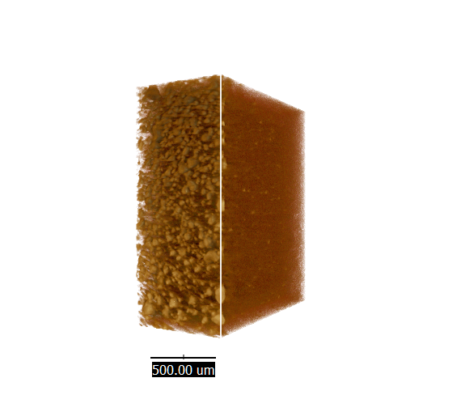
In this work, Sm³⁺-doped sodium yttrium borate glasses were studied and developed for X-ray detection. The influence of Sm₂O₃ concentration (0 - 2 mol%) on the glass physical, optical, and luminescence properties were investigated to find out the optimum glass composition.

The 4f-4f transition from ⁶H_{5/2} ground state of Sm³⁺ caused the glass’s absorption in visible light and near-infrared region which its absorption strength increased by following Sm₂O₃ content. Under excitation at 403 nm, glasses exhibited the strongest photoluminescence (PL) at 600 nm under Sm³⁺ transition from ⁴G_{5/2} luminescence level. The radioluminescence (RL) of glasses under X-ray excitation were investigated and their spectrum pattern were similar to those of PL. Glass doped with 1 mol%-Sm₂O₃ owned the highest emission intensity in both PL and RL spectra due to concentration quenching effect. Additionally, PL and X-ray scintillation decay time of glasses decreased in milliseconds range with added Sm₂O₃ concentration.
3D-image of Sponge captured by X-ray imaging used
1 mol%-Sm₂O₃ doped sodium yttrium borate glass as scintillator

Finally, 1 mol% doped glass was used as scintillator for practical X-ray imaging, and it yielded the satisfied quality of image compared to YAG:Ce scintillator. This developed glass is a promising material for static X-ray imaging and orange photonic applications.

