The development of new Ce³⁺ doped silicophosphate glass for X-ray scintillator and application to synchrotron x-ray imaging

E. Kaewnuam¹, N. Wantana^{2,3,*}, Y. Ruangtaweep^{2,3}, F. Khrongchaiyaphum^{2, 3}, N. Chanthima^{2, 3},
M. Tungjai⁴, P. Pakawanit⁵, C. Phoovasawat⁵, J.Y. Cho⁶, H.J. Kim⁷, N. Intachai⁴, S. Kothan⁴,
J. Kaewkhao^{2,3}

¹Faculty of Science and Technology, Muban Chombueng Rajabhat University, Ratchaburi, 70150,
Thailand
²Physics Program, Faculty of Science and Technology, Nakhon Pathom Rajabhat University, Nakhon Pathom, 73000, Thailand
³Center of Excellence in Glass Technology and Materials Science (CEGM), Nakhon Pathom Rajabhat University, Nakhon Pathom, 73000, Thailand
⁴Center of Radiation Research and Medical Imaging, Department of Radiologic Technology, Faculty of Associated Medical Sciences, Chiang Mai University, Chiang Mai, 50200, Thailand
⁵Synchrotron Light Research Institute (Public Organization), Synchrotron Research and Applications Division, 111 University Avenue, Muang District, Nakhon Ratchasima 30000, Thailand
⁶The Center for High Energy Physics, Kyungpook National University, Daegu, 41566, Republic of Korea
⁷Department of Physics, Kyungpook National University, Daegu, 41566, Republic of Korea

Corresponding Author Email: wnuanthip@webmail.npru.ac.th

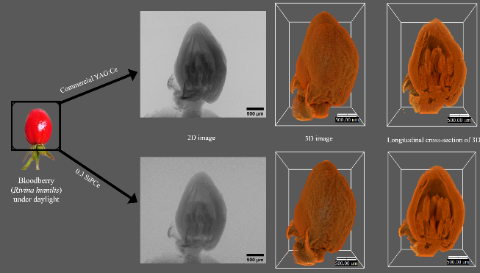
This work studied the effect of CeF₃ concentration on P₂O₅-Gd₂O₃-ZnO-Al₂O₃-Na₂CO₃-SiO₂-xCeF₃ glass properties to develop as the scintillator for X-ray imaging.

The density and refractive index of glass increased by more doping CeF₃ content. All glasses performed high transparency in visible light, while the absorption of Gd³⁺ and Ce³⁺ was obviously dominant in UV region on CeF₃-undoped and CeF₃-doped glasses respectively. Photoluminescence (PL) of glasses were investigated under direct Ce³⁺ excitation (λ_{ex} = 305 nm) and Gd³⁺ - Ce³⁺ energy transfer process (λ_{ex} = 275 nm). With direct Ce³⁺ excitation, glass exhibited the highest PL intensity of Ce³⁺ (5d → 4f) around 330 - 345 nm. This generated blue light emitting and its decay time of Ce³⁺ were short around tens of nanosecond order. PL intensity and decay time at 311 nm of Gd³⁺ in glass decreased via CeF₃ addition revealing the Gd³⁺ → Ce³⁺ energy transfer. The photoluminescence quantum yield of 0.30 mol%-CeF₃ doped glass with λ_{ex} = 305 nm and 275 nm was 34.95 % and 20.23 % respectively. Under X-ray excitation, this glass sample performed the strong emission with radioluminescence (RL) light at 95% of BGO scintillator. The light yield of glass irradiated by γ-ray (0.662 MeV) from ¹³⁷Cs source was around 220 ± 22 ph/MeV. This developed glass was used as scintillator for capturing the object which its image quality was slightly less than image by commercial YAG:Ce crystal. It represented the high performance of glass scintillator for practical X-ray imaging operation.
Synchrotron x-ray imaging of Bloodberry captured by using SiPCe glass as scintillator compared to YAG:Ce crystal

