From discrete-pixel scintillation detector matrices for X-ray scanners to integrated technology via a ceramic-based fabrication route

P.S. Sokolov¹, L.V. Ermakova¹, V.G. Smyslova¹, A.M. Sergeev^{1,2}, I.Yu. Komendo^{1,2},
V.A. Mechinsky^{1,3}, E.A. Borisevich³, M.V. Korzhik^{1,3}

¹National Research Centre «Kurchatov Institute», Moscow, Russia
²Mendeleev University of Chemical Technology of Russia, Moscow, Russia
³Institute for Nuclear Problems Belarus State University, Minsk, Belarus
Corresponding Author Emails: sokolov-petr@yandex.ru, sokolov_ps@nrcki.ru

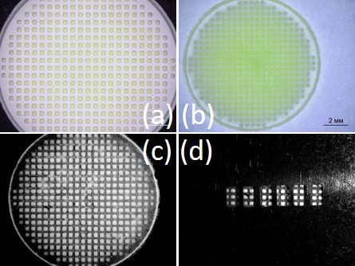
Array detectors based on inorganic scintillation materials are widely used in measurement equipment across various fields of science and technology. Their size can vary by orders of magnitude depending on their intended application. A large-scale 3D array detector—the electromagnetic calorimeter of the Compact Muon Solenoid (CMS) collaboration at the Large Hadron Collider (LHC), composed of over 90,000 lead tungstate PbWO₄ crystals—was a decisive factor in the discovery of the Higgs boson in 2012 at CERN. X-ray radiography and tomography utilize significantly smaller detector arrays, with individual detector elements (pixels) having cross-sectional dimentions measuring no more than one millimeter or even less. A very important application is X-ray scanning using flat panel detectors (FPDs) for both fluorography and mammography.
Figure 1. Optic images of pixelated composite structure, green body as-prepared by DLP 3D printing (a), ceramics after sintering (b), ceramics under UV LED light with-out (c) and with mire (d) [1].
In our recent work [1], planar ceramic scintillation elements were developed for the first time. Garnet-type materials were used for the substrate and square-shaped pixels: (Gd,Y)₃Al₂Ga₃O₁₂:Mg and (Gd,Y)₃Al₂Ga₃O₁₂:Ce,Mg, respectively. Green bodies were successfully fabricated using a digital light processing (DLP) 3D printing method (Fig.1a). Subsequent debinding process and pressureless high-temperature sintering formed composite elements consisting of two layers with different chemical compositions (Fig.1b). The lower bulk layer consisted of transparent, non-luminescent garnet, while the upper pixelated layer, with pixel dimensions of 230×230 µm, was made of scintillation material. The response of the elements to alpha and beta radiation from isotopic sources was studied. It has been shown that a 500 ppm Mg substrate concentration significantly suppresses the intrinsic scintillation of unactivated garnet, by at least a factor of 18. This ensures a high contrast between the bulk substrate and the pixel emission, even without filling the interpixel space with light-blocking material (Fig.1c&1d). The spatial resolution of the developed technology was determined to be approximately 0.4 times the pixel size, which enables its application in the fabrication of large-area planar detectors for X-ray imaging.

1. L.V. Ermakova et al., “Integrated manufacturing technology for scintillation ceramic matrix detectors for X-ray imaging,” Russian Journal of Inorganic Chemistry, 71, № 2 (2026) in press.

This work was supported by the Russian Science Foundation, grant № 22-13-00172-П, https://rscf.ru/en/project/22-13-00172/.

