Features of Czochralski growth of 2-inch Ce-doped Y-Al-Ga garnet crystals for scintillator applications

Yasuhiro Shoji¹, Kei Kamada^{1,3}, Vladimir Kochurikhin¹, Liudmila Gushchina¹, Hisato Suezumi², Masao Yoshino^{1,2}, Akira Yoshikawa^{1,2,3}

¹C&A corporation, Sendai, Japan
²Institute for Materials Research, Tohoku University, Sendai, Japan
³New Industry Creation Hatchery Center, Tohoku University, Sendai, Japan
Corresponding Author Email: y_shoji@c-and-a.jp

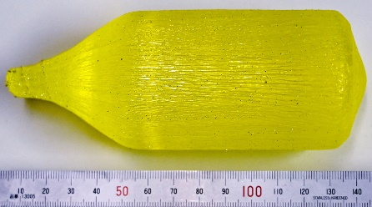
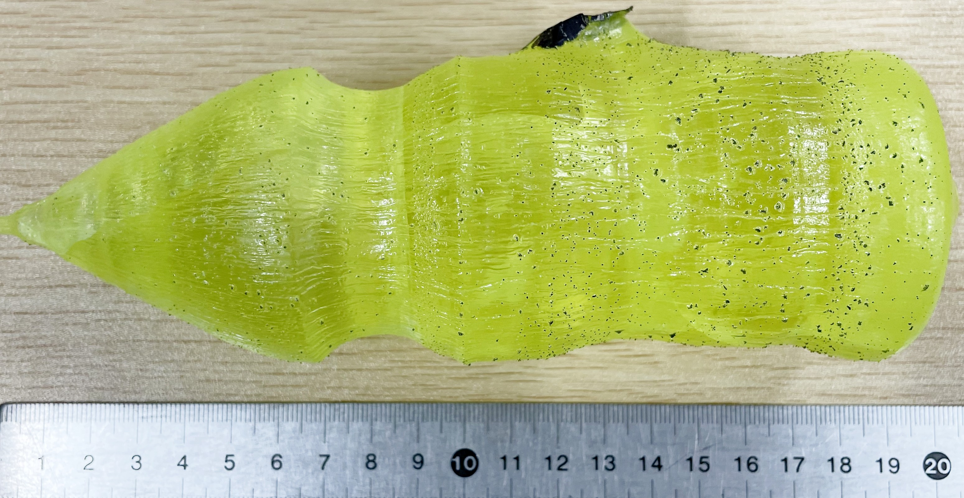

Recently, Ce-doped Gd-Al-Ga garnet single crystal (GAGG) have emerged as a promising scintillator material due to its high light yield (up to 53,000 photons/MeV) and fast decay times (76 and 794 ns). The growth technology for this crystal has been well developed, and boules up to 4 inches in diameter have been successfully grown [1].
Ce-doped Y-Al-Ga garnet (YAGG) is another prospective scintillator material mainly due to its shorter decay time in comparison with GAGG (20-40 ns). 1-inch YAGG crystals were successfully grown using the Czochralski technique [2].

However, our attempts to grow 2-inch YAGG crystals under the same conditions used for GAGG resulted in a significant deterioration in crystal quality. The melting temperature of YAGG is approximately 100 °C higher, leading to intense Ga₂O₃ evaporation during growth and a highly nonuniform composition along the length of the crystal. In addition, the irreversible loss of iridium (the crucible material) during a single YAGG growth cycle reached 6.2%, significantly increasing production costs. Moreover, small iridium particles floating on the melt surface caused substantial distortion of the cylindrical shape of the crystal.
GAGG and YAGG 2-inch crystals grown under the same conditions

Careful optimization of the growth conditions—including the ceramic hot-zone structure, growth parameters, melt composition, and growth atmosphere—resulted in a significant improvement in the quality of the grown 2-inch YAGG crystals. In particular, replacing the conventional N₂ + CO₂ growth atmosphere used for large GAGG crystals with Ar + O₂ reduced iridium loss to 1.6%. Careful selection of the hot-zone configuration also helped to prevent crack formation in the crystals.

In this report, we compare the optical and scintillation properties of 2-inch YAGG crystals grown under different conditions with those of commercially available large GAGG crystals.

- V. Kochurikhin et al. “Czochralski growth of 4-inch diameter Ce: Gd₃Al₂Ga₃O₁₂ single crystals for scintillator applications”, J. of Crystal Growth 531, 125384 (2020)
- O. Sidletskiy et al. “Structure and scintillation yield of Ce-doped Al-Ga substituted yttrium garnet”, Materials Research Bulletin, 47, 3249-3252 (2012)

