Scintillation Properties of Large BSO Crystals for Future High-Energy Physics Experiments

Mingxue Deng^{1, 2}, Wenpeng Li¹, Jian Zhang^{1, 2}, Junfeng Chen^{1, 2}, Dong Wang^{1, 2}

¹State Key Laboratory of Functional Crystals and Devices, Shanghai Institute of Ceramics, Chinese Academy of Sciences, 201899 Shanghai, China
²Center of Materials Science and Optoelectronics Engineering, University of Chinese Academy of Sciences, Beijing 100049, China
Corresponding Author Email: jfchen@mail.sic.ac.cn

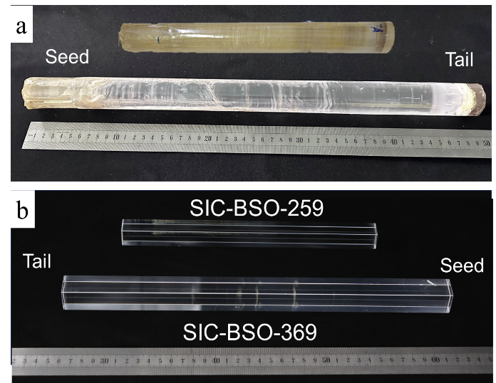
As a classic scintillator, BGO crystal is widely used in high-energy physics, nuclear medical imaging, nuclear physics, oil-well logging, etc. Compared with BGO crystal, bismuth silicate (Bi₄Si₃O₁₂, BSO) crystal offers a comparable stopping power and density while providing a faster decay time, superior radiation hardness, and markedly lower raw-material cost etc. These advantages make it a promising scintillator for future high energy physics experiments [1]. However, the difficulty in growing large, high-quality crystals significantly limits the practical application of BSO crystal, due to its isothermal melting and great differences in melting point and density of raw materials. And the longest BSO crystal reported to date measures 210 mm [2].
In this study, BSO crystal with dimensions of 22.6 mm × 22.6 mm × 369 mm (SIC-BSO-369) and 18.6 mm ×18.6mm×259 mm (SIC-BSO-259) were successfully processed from large ingots. Their scintillation properties, including transmittance, photoluminescence, X-ray excited emission, energy resolution, and light response uniformity, were characterized. The results show that the SIC-BSO-259 crystal exhibits a high longitudinal transmittance (78.32%@480 nm) close to the theoretical limit value, demonstrating excellent optical quality. Due to internal scattering, the longitudinal transmittance of the SIC-BSO-369 crystal is 45.27% at 480 nm. The average energy resolution of the SIC-BSO-259 and SIC-BSO-369 for 662 keV gamma rays are 27.2% and 29.0%, respectively. And their average absolute light output is 776 and 735 ph/MeV with relative uncertainty of 0.26%, respectively. When using ESR-wrapped fully polished SIC-BSO-259 crystal, the optical response uniformity (δ value) at the seed and the tail end of crystal coupling were (-1.19 ± 0.5) % and (-0.52 ± 0.5) %, respectively, superior to the previously reported ±2% for 188 mm and 187 mm long BSO crystals [3], demonstrating excellent optical response uniformity. The optimal light response uniformity (δ value) of SIC-BSO-369 is (1.41±1.78) % with Tyvek wrapped. This work has initiated the growth and performance study of ultra-large BSO crystals up to 37 cm in length, which is of great significance for promoting the application of BSO in the field of high-energy physics and nuclear physics experiments.
Figure. a. BSO crystal ingots with φ30 mm×300 mm and φ33 mm×495 mm including the seed crystal grown by SICCAS. b. The first 18.6 mm × 18.6 mm × 259 mm (up) and 22.6 mm × 22.6 mm × 369 mm (down) BSO crystals.
1. B. Qi and Y. Liu, “R&D of a Novel High Granularity Crystal Electromagnetic Calorimeter,” Instruments, 6, 3(2022).
2. T. Ishikawa et al., “A detailed test of a BSO calorimeter with 100–800 MeV positrons,” Nuclear Instruments and Methods in Physics Research Section A: Accelerators, Spectrometers, Detectors and Associated Equipment, 694,1 (2012).
3. M. Ishii et al., “Development of BSO (Bi₄Si₃O₁₂) crystal for radiation detector, ” Optical Materials, 19, 1 (2002).

