Thallium-based new high-density scintillator crystal: Tl₂SiF₆

D. Joseph Daniel¹, Sunghwan Kim², and H. J. Kim^{1,*}

¹The Center for High Energy Physics, Kyungpook National University, Daegu 41566, Republic of Korea
²Department of Radiological Science, Cheongju University, Cheongju, 28503, South Korea
*Corresponding Author Email: hongjoo@knu.ac.kr

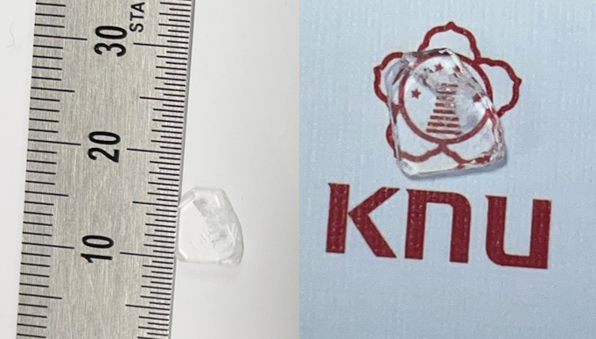

Heavy metal ions with an ns² electronic configuration typically give rise to pronounced luminescence under ambient conditions due to their favorable electronic transitions [1]. Consequently, thallium-based scintillator crystals have attracted growing interest, as their high density and large effective atomic number enable efficient absorption of high-energy X-rays and γ-rays, making them promising candidates for radiation detection applications [2]. In this present investigation, for the first time, we report that the scintillation properties of Dithallium hexafluorosilicate (Tl₂SiF₆) crystal scintillator. The single crystals were grown using the solvothermal method. Fig. 1 presents a digital photograph of the grown single crystal. In contrast to previously reported thallium-based halide scintillators that exhibit hygroscopic behavior, the grown crystals are non-hygroscopic and stable under ambient conditions. Structural analysis reveals that the grown crystal Tl₂SiF₆ crystallizes in the cubic crystal system with the space group$Fm\overline{3}m$. Under X-ray excitation, the Tl₂SiF₆ crystal exhibits a strong intrinsic emission band maximum at 298 nm. The scintillation decay measurements performed under γ-ray excitation from a ¹³⁷Cs source reveal a dominant decay component of 228 ns, contributing approximately 94% of the total emission intensity. Further investigations of the scintillation response and other relevant material properties will be discussed in detail.
Figure 1. Digital photograph of a grown scintillator single crystal: Tl₂SiF₆

References:
- A. Vogler and H. Nikol , The structures of s² metal complexes in the ground and sp excited states. Comments Inorg. Chem., 1993, 14 , 245 – 261.
- HongJoo Kim et al., Thallium-based heavy inorganic scintillators: recent developments and future perspectives. : CrystEngComm, 2022, 24, 450.

