Temperature-driven changes in photoluminescence and pulsed photoluminescence of Xe-irradiated MgAl₂O₄ single crystals

Abdirash Akilbekov¹, Vladimir Skuratov², Nikita Kirilkin², Gulnara Aralbayeva¹, Zhuldyz Ospanova¹, Alma Dauletbekova¹

¹L.N. Gumilyov Eurasian National University (ENU), 010008 Astana, Kazakhstan
²Joint Institute for Nuclear Research, Dubna, Russian Federation
Corresponding Author Email: akilbekov_at@enu.kz

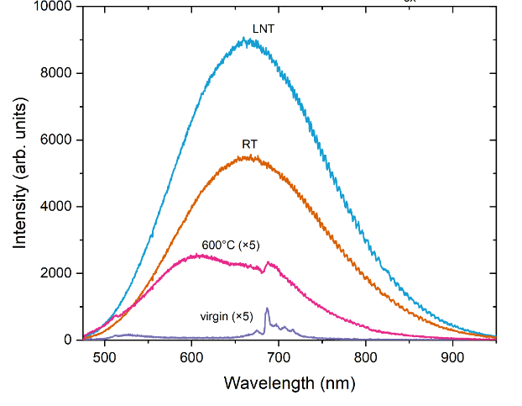
MgAl₂O₄ spinel exhibits exceptional resistance to fast neutron irradiation, making it a promising material for optical and diagnostic windows in future fusion reactors. It also demonstrates high stability under irradiation with energetic ions, enabling its use as an inert matrix for nuclear fuels and as a waste-immobilization material. In addition, MgAl₂O₄ crystals are widely employed as hosts for various laser media, phosphors for solid-state lighting, scintillators, and as substrates for thin-film growth. The structural and, in particular, the optical properties of spinel under swift heavy ion (SHI) irradiation are of significant interest.

In this work, MgAl₂O₄ crystals were irradiated at the DC-60 accelerator (Astana, Kazakhstan) with 230 MeV ¹³²Xe ions at temperatures of 77 K, 300 K, and 870 K. The electronic and nuclear stopping powers were S_{e} = 24.2 keV/nm and S_{n} = 0.07 keV/nm respectively with an ion projected range of 14.7 μm. Photoluminescence (PL) and pulsed photoluminescence (PPL) measurements were performed using a confocal microscope in reflection geometry with 445 nm laser excitation. Decay kinetics were recorded with a PMA 175 photomultiplier and a TimeHarp TCSPC system (time resolution <0.2 ns).

The PL spectra measured from the surface of irradiated samples exhibit a broad band with a maximum at approximately 660 nm. The spectrum for irradiation at liquid-nitrogen temperature (LNT) shows the highest intensity, likely due to more efficient heat dissipation from the ion track region, which reduces thermal recovery and leads to a higher concentration of radiation-induced defects compared with room temperature irradiation.

Decay curves for RT and LNT-irradiated samples exhibit similar behavior, whereas those for samples irradiated at 870 K show slightly altered decay. Each curve consists of at least two components: the fast component has lifetimes of 4.1 ns (RT), 4.4 ns (LNT), and 6.4 ns (870 K), while the slow component has lifetimes of 12.8 ns, 12.9 ns, and 13.4 ns, respectively. These results provide insight into the temperature-dependent formation, clustering, and thermal recovery of radiation-induced defects in MgAl₂O₄ under SHI irradiation.

The investigations were funded by the Science Committee of the Ministry of Science and Higher Education of Kazakhstan (grant N AP23488607).

