Optimization of Nano-scale TiO₂ Reflectors via Atomic Layer Deposition for High-Resolution Scintillation Detectors

Sangsu Kim¹, Chansun Park¹, Hyojung Kim², Mingu Kim⁵, Shinhaeng Cho², Jung-Yeol Yeom^{3,4,*}

¹Global Health Technology and Research Center, Korea University, Seoul, Republic of Korea
²Department of Radiation Oncology, Chonnam National University Medical School, Gwangju, Republic of Korea
³Department of Bioengineering, Korea University, Seoul, Republic of Korea
⁴School of Bioengineering, Korea University, Seoul, Republic of Korea
⁵Department of applied physics, Korea University, Sejong, Republic of Korea

Corresponding Author Email: jungyeol@korea.ac.kr

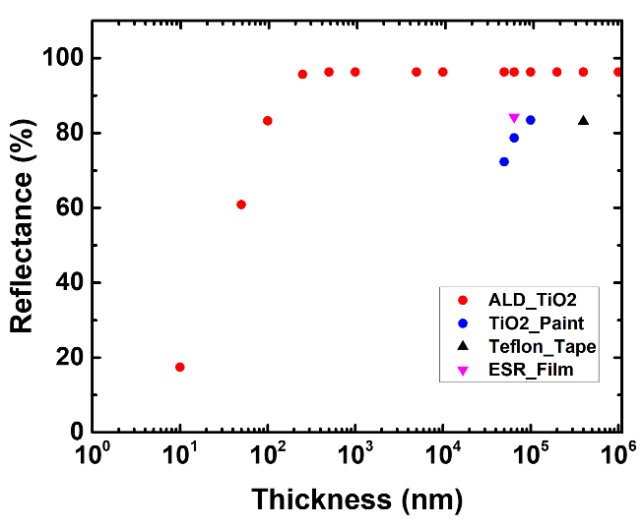
High-resolution scintillation detector arrays require ultra-thin reflectors to minimize dead space and maximize the fill factor. In this study, we investigate the feasibility of sub-micron titanium dioxide (TiO₂) thin films, deposited via Atomic Layer Deposition (ALD), as a replacement for conventional bulky reflector materials. Based on our previous experimental results [1], widely used reflectors such as Teflon tape, ESR film, and TiO₂ paint require substantial thicknesses—up to 400 μm, 65 μm, and 138 μm, respectively—to achieve optimal reflectance. Optical simulations performed using the Transfer Matrix Method (TMM) indicate that an ALD-deposited TiO₂ film with a thickness of only 250 nm can achieve a reflectance of 95.7%, which is comparable to that of a 400 μm-thick Teflon reflector. This enhanced performance is attributed to the high refractive index of the dense TiO₂ phase (n ~2.5) and the elimination of the interfacial air gaps. As shown in Fig. 1, the ALD-based nano-reflector reaches its reflectance saturation at a thickness approximately three orders of magnitude thinner than that of conventional reflector materials. These findings demonstrate that ALD-fabricated nano-reflectors can significantly reduce detector volume while preserving high light collection efficiency, thereby enabling the development of next-generation, high-resolution scintillation detectors for medical imaging systems. Further experimental validation and detailed analyses will be presented at the conference.
Fig. 1. Comparison between the simulated reflectance curve of ALD TiO₂ and discrete experimental data points for Teflon tape, ESR film, and TiO₂ paint. The ALD thin film achieves high reflectance at only 250 nm thickness, offering a 1,600-fold reduction in thickness compared to the 400 μm Teflon reference.

References
- C. Park et al., “Compatibility of TiO2 reflective material with Ce:GAGG scintillators in harsh environments,” Optical Materials, 157, 116165 (2024).

Acknowledgments
This work was supported by the National Research Foundation of Korea (RS-2023-00240040, RS-2023-00234651, RS-2023-NR077190, RS-2025-00561749), Chonnam National University’s Hwasun Hospital Institute for Biomedical Science (HCRI23-034), and Korea University Grant.

