Melt-Growth of Cs₃Cu₂I₅ Single Crystals: Growth Behavior and Inch-Sized Scintillation Performance

Yuntao Wu,* Qian Wang, Qiang Gao
State Key Laboratory of Functional Crystals and Devices, Shanghai Institute of Ceramics, Chinese Academy of Sciences, Shanghai, China
Corresponding Author Email: ytwu@mail.sic.ac.cn

Recently developed low-dimensional metal halides have emerged as promising scintillators due to non-hygroscopicity, self-absorption-free, and high-scintillation-yield, in which the functional clusters are spatially separated from each other by ions or groups with large steric hindrance. Among them, Cs₃Cu₂I₅ has superior scintillation performance and physical properties, such as high effective atomic number and density, non-hygroscopicity, low melting point, and absence of intrinsic radioactivity. Nonetheless, the development of inch-size single crystals, urgently needed in practical applications, has not been achieved yet. Also, the scintillation performance of large-size single crystals remains to be validated.
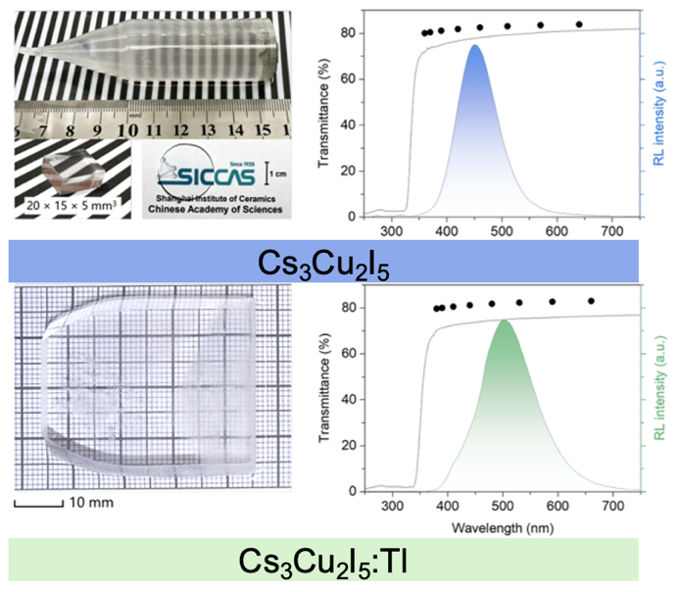
In this work, the crystal growth behaviors of Cs₃Cu₂I₅ during melt growth processes are comprehensively studied, and optimized Bridgman-growth procedures are developed to obtain inch-sized single crystals. The compositional precipitation during growth is revealed, such as the formation of CsI inclusions caused by the peritectic reaction. The low heat capacity, large anisotropic thermal expansion, low thermal conductivity, low hardness, and low fracture toughness result in the tendency to cracking during growth. By optimizing the Bridgman growth parameters, high quality of Tl-doped Cs₃Cu₂I₅ single crystal with a size of 40 mm × 35 mm × 5 mm can be obtained. It has a high light yield of 90,000 ± 3,000 photons/MeV and a decent energy resolution of 4.0 ± 0.2% at 662 keV. This work establishes a pathway for scalable growth of high-performance Cs₃Cu₂I₅-based single crystals for various radiation detection applications.
The as-grown crystal ingot and polished labs of Cs₃Cu₂I₅ and Cs₃Cu₂I₅:Tl. The optical transmission and X-ray radioluminescence spectra.

1. S. Cheng, A. Beitlerova, R. Kucerkova, et al. “Zero-dimensional Cs₃Cu₂I₅ perovskite single crystal as sensitive X-ray and γ-ray scintillator,” Phys. Status Solidi Rapid Res. Lett. 14, 2000374 (2020).
2. D. Yuan, “Air-stable bulk halide single-crystal scintillator Cs₃Cu₂I₅ by melt growth: intrinsic and Tl doped with high light yield,” ACS Appl. Mater. Interfaces 12, 38333 (2020).
3. L. Stand, D. Rutstrom, M. Koschan, et al. “Crystal growth and scintillation properties of pure and Tl-doped Cs₃Cu₂I₅,” Nucl. Instrum. Methods Phys. Res. A 991, 164963 (2021).
4. S. Cheng, M. Nikl, A. Beitlerova, et al. “Ultrabright and highly efficient all‐inorganic zero‐dimensional perovskite scintillators,” Adv. Opt. Mater. 9, 2100460 (2021).

This research received the support from the National Natural Science Foundation of China (12305211, 12575331, 12575203), the CAS Project for Young Scientist in Basic Research (YSBR-024).

