Research on the novel glass scintillator for high-energy radiation detection

Sen Qian^{1*}, Hua Cai², Kun Ge³, Zhehao Hua^{1,2,4} Jifeng Han⁵, Peng Hu⁶, Weichang Li⁷, Xingcan Li^{1,8}, Xusheng Qiao⁹, Jing Ren⁸, Xinyuan Sun¹⁰, Gao Tang¹¹, Dong Yang³

¹ Institute of High Energy Physics, Chinese Academy of Sciences, Beijing, China
² China Building Materials Academy, Beijing, China
³ Beijing Glass Research Institute, Beijing, China
⁴ School of Materials Science and Engineering, Wuhan University of Technology, Wuhan, China
⁵ Key lab of Radiation Physics and Technology of MOE, Sichuan University, Chengdu, China
⁶ China Nuclear (Beĳing) Nuclear Instrument CO.,LTD., Beĳing, China
⁷ Shanghai Institute of Optics and Fine Mechanics, Chinese Academy of Sciences, Shanghai, China
⁸ College of Physics and Optoelectronic Engineering, Harbin Engineering University, Harbin, China
⁹ School of Materials Science and Engineering, Zhejiang University, Hangzhou, China
¹⁰ Department of Physics, Jinggangshan University, Ji'an, China
¹¹ College of Materials and Chemistry, China Jiliang University, Hangzhou, China
Corresponding Author Email: qians@ihep.ac.cn

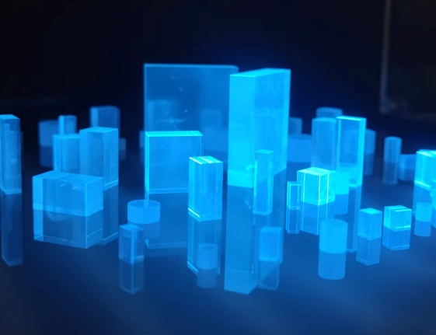
Ce³⁺-doped scintillation materials, endowed with a unique transition mechanism, exhibit the combined advantages of fast decay time and high luminescence efficiency, thus finding widespread applications in the fields of national defense security inspection, medical imaging and high-energy physics. Glass Scintillator exhibits significant application potential in medical positron emission tomography (PET) and large scientific installations, owing to its low cost, continuously tunable composition design, and feasibility for large-scale fabrication. However, achieving high density, high light yield, and fast decay time simultaneously in glass scintillator remains a critical challenge in this field, which also constitutes a major bottleneck hindering the development of radiation detectors. In 2021, the Institute of High Energy Physics (IHEP) of the Chinese Academy of Sciences collaborated with multiple research institutions to establish the Glass Scintillator Collaboration, aiming to develop novel glass scintillator materials. Currently, the collaboration has successfully developed a series of high-performance glass scintillators. Among them, the silicate and borate glasses achieve a density of 6 g/cm³, an energy resolution better than 26%@662 keV, and a light yield up to 1100 ph/MeV. Notably, the borate glass exhibits a light yield exceeding 2400 ph/MeV. Moreover, large-scale scintillating glass with a light output of 1200 ph/MeV has been industrially produced in batch quantities. Additionally, the Ce³⁺-doped nanoglass composites developed by the collaboration have achieved a light yield of 3400 ph/MeV, representing one of the highest light yield levels attained within the glass scintillator systems to date. The collaboration has actively promoted the application research of scintillation glasses in large scientific installations, systematically carried out energy deposition response tests of scintillation glasses under the irradiation of different particles (including muons, electrons, pions, protons and photons), and evaluated their radiation hardness in proton beam and gamma ray irradiation environments. Meanwhile, based on the Monte Carlo simulation method, the comparative verification of experimental data and simulation results has been completed. Driven by the rapid development of high-energy physics and nuclear radiation detection fields, the Glass Scintillator Collaboration continues to devote itself to the research and development of high-performance scintillation glasses and strives to promote their translation toward practical engineering applications.
Glass scintillator samples

