Effect of Tertiary and Quaternary Polystyrene-Based Plastic Scintillators on Energy Transfer Efficiency in Radiation Detection
Rajesh Paulraj¹*, Mohit Tyagi²
¹Scintillation Materials Laboratory, Department of Physics, Sri Sivasubramaniya
Nadar College of Engineering (SSNCE), Kalavakkam, Tamilnadu, India - 603 110.
²Crystal Technology Section, Technical Physics Division, Bhabha Atomic Research Centre (BARC), Mumbai, India – 400 085.
Corresponding Author Email: rajeshp@ssn.edu.in
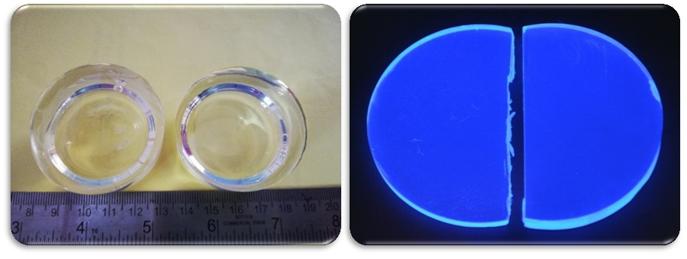
This paper discusses the fabrication of two polystyrene-based plastic scintillators by thermal polymerization and the evaluation of their scintillation efficiency. The former is a tertiary scintillator doped with 1 wt.% 2,5-diphenyloxazole (PPO) and 0.05 wt.% 1,4-bis[2-(phenyloxazolyl)]-benzene (POPOP) and the latter is a quaternary scintillator with 1 wt.% 2,5-diphenyloxazole (PPO), 0.5 wt.% stilbene and 0.05 wt.% 1,4-bis[2-(phenyloxazolyl)]-benzene (POPOP). The amorphous structure and high optical transparency of the fabricated scintillators were determined from XRD and UV-Vis-NIR analysis. The luminescence spectra for both scintillators show a maximum peak at 423 nm with high fluorescence intensity for the tertiary plastic scintillator. The decay time of 2 ns and 3 ns respectively, for the tertiary and the quaternary plastic scintillators reveals their fast response time. Pulse height spectra were obtained using three conventional gamma-ray sources, namely, ¹³⁷Cs, ⁶⁰Co, and ²²Na. Calibration of the Compton energy was achieved by examining the position of the Compton edge within the Compton spectra. The produced scintillators exhibited an excellent energy linearity of 98% for tertiary and 94% for quaternary plastic scintillators respectively. The excellent scintillation performance of the tertiary scintillator also reports a noticeable relatively higher light yield of 30% to that of trans-stilbene crystal and is worth considering for radiation detection events [1-3].
b
a
Figure 1:Fabricated tertiary and quaternary plastic scintillators under
(a) white and (b) UV light

References
[1] Sauli, F., 2015. Gaseous radiation detectors: fundamentals and applications, Cambridge University Press, 497.
[2] Govindan, V., Daniel, D. J., Kim, H. J., Sankaranarayanan, K., 2019. Crystal growth and characterization of 1, 3, 5-triphenylbenzene organic scintillator crystal. Mater. Chem. Phys. 223, 183-189.
[3] Zaitseva, N.P., Newby, J., Hamel, S., Carman, L., Faust, M., Lordi, V., Cherepy, N.J., Stoeffl, W., Payne, S.A., 2009. Neutron detection with single crystal organic scintillators. In Hard X-Ray, Gamma-Ray, and Neutron Detector Physics XI, SPIE. 7449, 207-216.

