Fabrication and properties of Tb-doped gadolinium oxysulfide scintillation ceramics for neutron imaging

Jiang Li^{1,2}, Junlin Wu^{1,2}, Dong Huang^{1,2}, Chen Hu^{1,2}, Jianrong Zhou³, Zhijia Sun³, Dariusz Hreniak⁴,

¹State Key Laboratory of High Performance Ceramics, Shanghai Institute of Ceramics, Chinese Academy of Sciences, Shanghai 201899, China
²Center of Materials Science and Optoelectronics Engineering, University of Chinese Academy of Sciences, Beijing 100049, China
³Spallation Neutron Source Science Center, Dongguan 523803, Guangdong, China
⁴Institute of Low Temperature and Structure Research, Polish Academy of Sciences, Okólna 2, 50-422 Wroclaw, Poland

Corresponding Author Email: lijiang@mail.sic.ac.cn

This is Neutron imaging in ray non-destructive detection has been widely studied due to its great application advantages. Terbium-doped gadolinium oxysulfide (Gd₂O₂S:Tb) scintillation powders have excellent application prospects in neutron imaging due to its high neutron absorption cross-section, high X-ray blocking ability, high light output and good physicochemical stability. The Gd₂O₂S powder scintillation screens prepared by Paul Scherr Institute (PSI) in Switzerland have shown very high application performance.

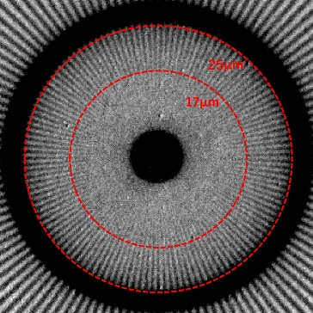
In this work, the Gd₂O₂S:Tb powders with smaller lamellar particle size and more uniform dispersion were obtained by the hot water-bath method h. Gd₂O₂S:Tb ceramics with the highest total optical transmittance of 20.3% at 545 nm and highest X-ray excited luminescence (XEL) intensity were obtained by hot pressing and HIP post-treatment. The XEL intensity of Gd₂O₂S:Tb ceramics is highest when the air-annealing temperature is 900ºC, which is 1.3 times of that before annealing, and its neutron light output is 264 ph/n. The spatial resolution of neutron imaging of Gd₂O₂S:Tb ceramics (30 μm in thickness) is 17 μm, which is better than that of the Gd₂O₂S:Tb powder screen (20 μm) from PSI.
Neutron signal charge spectrum (the left) and Neutron spatial resolution (the right) of Gd₂O₂S:Tb ceramics.

1. Junlin Wu, Jiyang Ding, Xinyou Huang, et al. Fabrication and microstructure of Gd₂O₂S:Tb scintillation ceramics from water-bath synthesized nano-powders: The influence of H₂SO₄ to Gd₂O₃ mole ratio. J. Inorg. Mater., 2023, 38(4): 452-460.
2. Junlin Wu, Dong Huang, Chen Hu, et al. Influence of LiF contents on the microstructure and optical properties of Gd₂O₂S:Tb scintillation ceramics. Opt. Mater., 2025, 168: 117439

Acknowledgments should appear near the bottom of the page.

This work was supported by the National Science and Technology Major Project (Grant No. 2024ZD0605900).

