Defect Engineering in LuAG:Ce Ceramics: Towards Ultrahigh Fast Scintillation Proportion

Chen Hu^{1,2}, Danyang Zhu^{1,2}, Yanbin Wang^{1,2}, Romana Kucerkova³, Alena Beitlerova³, Martin Nikl³, Jiang Li^{1,2,*}

¹State Key Laboratory of High Performance Ceramics, Shanghai Institute of Ceramics, Chinese Academy of Sciences, Shanghai 201899, China
²Center of Materials Science and Optoelectronics Engineering, University of Chinese Academy of Sciences, Beijing 100049, China
³Institute of Physics of the Czech Academy of Sciences, Cukrovarnicka 10, Prague 16200, Czech
Corresponding Author Email: lijiang@mail.sic.ac.cn

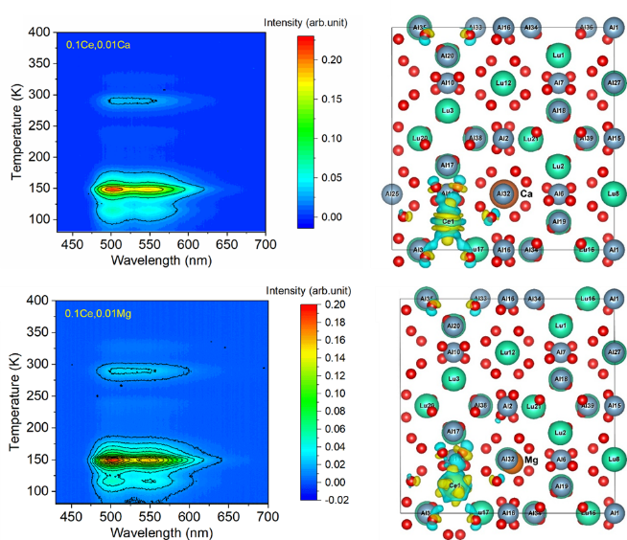
Future high energy physics (HEP) experiments at the energy and intensity frontiers present stringent challenges to inorganic scintillators in radiation hardness, fast time response and cost. Inorganic scintillators in ceramic form have attracted a broad interest due to its lower fabrication temperature, effective usage of raw material, and no need for aftergrowth mechanical processing. In this work, recent progress on defect engineering in radiation hard, fast, and cost-effective LuAG:Ce transparent ceramic scintillators for future HEP experiments was reported. Co-dopants, such as Ca²⁺ and Mg²⁺, were used to improve fast scintillation proportion of LuAG:Ce ceramics. Results of their optical and scintillation performance will be presented. The improvement on fast scintillation proportion was further confirmed by thermoluminescence (TSL) results. The different behavior of Ca²⁺ and Mg²⁺ co-doping was explained by the density functional theory (DFT) calculations. As a consequence, both Ca²⁺ and Mg²⁺ co-doped ceramic samples show a fast-total ratio above 98% [1,2]. Future plan concerning other garnet scintillators will also be presented.
Contour plot of wavelength-resolved TSL measurement performed on LuAG:Ce,Ca and LuAG:Ce,Mg ceramics; Charge density difference between excited state and ground state of LuAG:Ce,Ca and LuAG:Ce,Mg.

1. C. Hu, D.Y. Zhu, Y.B. Wang, et al., “Effect of Ca content on optical, scintillation and thermoluminescence performance of LuAG:Ce ceramic scintillators,” Journal of Luminescence, 282, 121245 (2025).
2. C. Hu, D.Y. Zhu, Y.B. Wang, et al., “Defect engineering in Mg²⁺ co-doped LuAG:Ce ceramics: Towards ultrahigh fast scintillation proportion,” Journal of Advanced Ceramics, 14, 9221148 (2025).

Acknowledgments
This work was supported by the National Natural Science Foundation of China (No. 12175254), and the Shanghai High-Level Talent Plan and the Opening Fund of the Key Laboratory of Rare Earths, Chinese Academy of Sciences.

