Optical and Scintillation properties of Mixed Halide Li₂Hf(Br,I)₆ for Thermal Neutron Detection

Chihaya Fujiwara^{1,2}, Shunsuke Kurosawa^{3,4}, Akihiro Yamaji⁵, Akira Yoshikawa^{2,4,6}

¹ Institute for Materials Research, Tohoku University, Sendai, Miyagi, Japan
² Department of Materials Science, Graduate School of Engineering, Tohoku University, Sendai, Miyagi, Japan,
³Nanosystem Integration Center, School of Engineering, The University of Tokyo, Tokyo, Japan
4 Institute of Laser Engineering, Osaka University, Suita, Osaka, Japan
5 Research Center for Neutrino Science, Tohoku University, Sendai, Miyagi, Japan
6 New Industry Creation Hatchery Center, Tohoku University, Sendai, Miyagi, Japan
Corresponding Author Email: fujiwara.chihaya.p8@dc.tohoku.ac.jp

Zero-dimensional (0D) vacancy-ordered perovskite halides A₂BX₆ (A = Cs; B = Hf, Zr; X = Cl, Br, I) have emerged as promising scintillator materials due to their efficient luminescence originating from self-trapped excitons (STEs) within spatially isolated [BX₆]²⁻ octahedral clusters [1]. However, research has primarily focused on gamma-ray and X-ray detection, and their application to neutron scintillators remains unexplored. Regarding neutron detection, there is an urgent need for alternative materials due to supply concerns regarding ³He gas-based detectors arising from resource scarcity [2]. In this study, we developed Li₂HfX₆ (X = Cl, Br, I) scintillators by incorporating ⁶Li—which possesses a high neutron capture cross-section—into the A-site, aiming to realize a novel, high-sensitivity neutron scintillator with high light yield.
The Li₂HfX₆ crystals were synthesized using the melting growth and Bridgman-Stockbarger method. To clarify the emission mechanism, the temperature dependence of the luminescence properties was characterized. Furthermore, first-principles calculations were performed using VASP [3] to evaluate the bandgap, density of states (DOS), and charge density distribution.
Figure 1 shows the excitation (dashed line) and emission (solid line) spectra of the bromine-iodine mixed-halide system, Li₂HfBr_{6-x}I_{x} (0 ≤ x ≤ 6). The results revealed that the emission wavelength reaches a maximum at Li₂HfBr₄I₂ and subsequently undergoes a blue shift as the iodine content increases. This behavior was anomalous, as it is opposite to the trend observed in typical mixed-halide perovskites. Analysis of the temperature dependence of the emission spectra revealed that the blue shift induced by iodine substitution was attributed to the emergence of luminescence originating from free excitons with higher energy emission band. In the upcoming presentation, we will discuss the origins of this unique emission shift and the neutron detection performance, incorporating insights from our first-principles calculations.
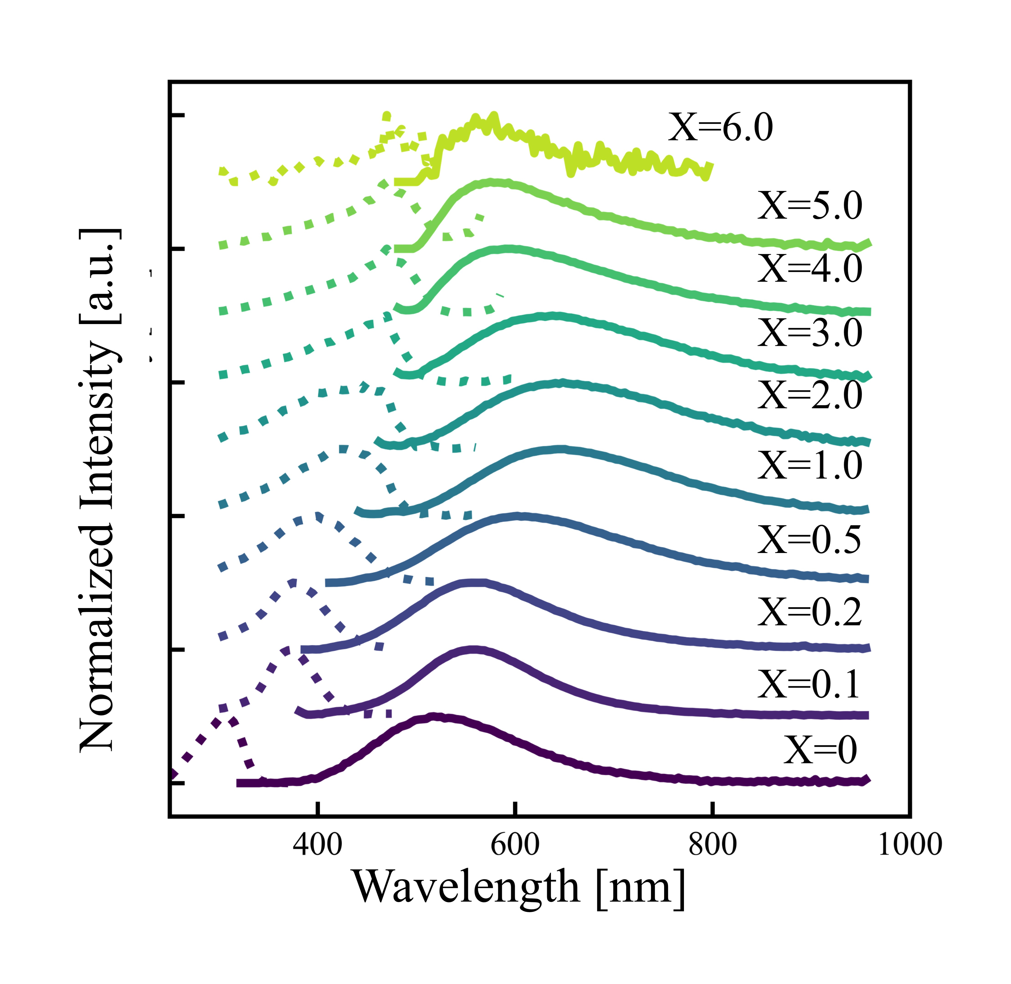
Fig. 1 (a) Emission (solid line) and excitation (dotted line) spectra of Li₂HfBr_{6-x}I_{x}.

References
[1] A. Burger et al., Appl. Phys. Lett., vol. 107, no. 14, pp. 2–6, 2015.
[2] R. T. Kouzes et al. , Nucl. Instrum. Methods Phys. Res. A, vol. 784, pp. 172–175, 2015.
[3] P. E. Blöchl, Phys. Rev. B Condens. Matter, vol. 50, no. 24, pp. 17953–17979, Dec. 1994.

