Targets and Challenges in Fast-Timing Garnets

Oleg Sidletskiy^{1,2}, Iaroslav Gerasymov¹, Denys Kofanov¹, Kheirreddine Lebbou³,
Loris Martinazzoli^{4,5}, Julie Delenne^{4,6}, Louis Roux^{3,4}, Etiennette Auffray⁴

¹Institute for Scintillation Materials NAS of Ukraine, Kharkiv, Ukraine.
²Centre of Excellence ENSEMBLE3 Sp. z o. o, Warsaw, 01-919, Poland.
³Université Lyon, Université Claude Bernard Lyon 1, Institute Lumière Matière
UMR 5306, CNRS, Villeurbanne, 69100, France
⁴European Organization for Nuclear Research (CERN), Geneva, Switzerland
⁵INFN & Università degli Studi di Milano-Bicocca, Milan, Italy
⁶Université de Strasbourg, UMR7178, CNRS, IPHC, Strasbourg, France
Corresponding Author Email: sidletskiy@isma.kharkiv.ua

Fast-timing garnet scintillators are intensively studied to meet the requirements of next-generation particle physics experiments [1], while also being attractive for medical imaging. Cerium is still the optimal activator because it provides bright and fast luminescence in garnet hosts in the visible spectral range, with decay times of several tens of nanoseconds; however, this remains significantly longer than the 10–15 ns target required in high-energy physics. Shortening the decay time is commonly achieved at the expense of light output by luminescence quenching through codoping with divalent ions such as Ca²⁺ and Mg²⁺, which introduce non-radiative processes and Ce³⁺→Ce⁴⁺ conversion [2-4].
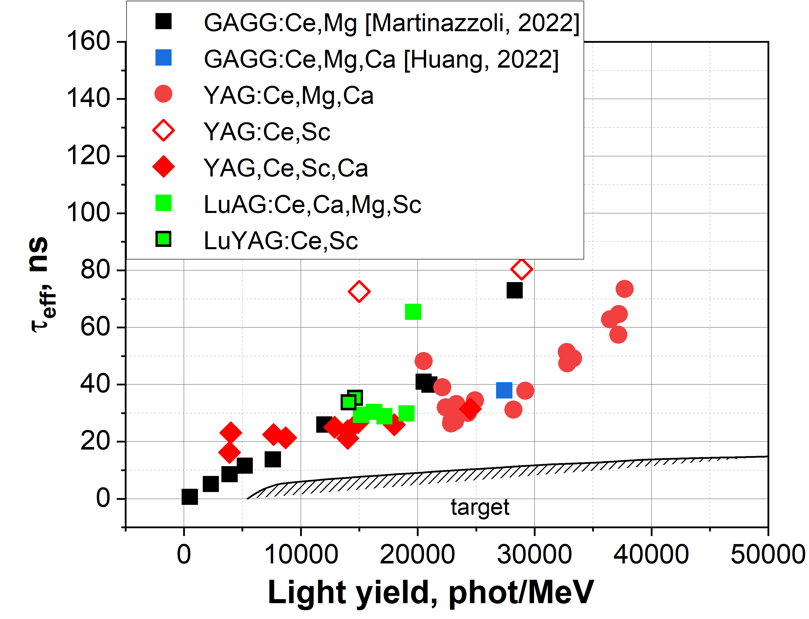
Correlation between effective decay time
and light output in some Ce-doped garnets.
This report overviews recent advancements in fast-timing Ce-doped garnets and addresses passways to achieve the target parameters and decrease crystal production cost. The most notable progress has been demonstrated in GAGG:Ce where the decay was accelerated below 1 ns albeit at the expense of severe quenching of the light output [5,6]. Ga-free alternatives such as codoped YAG:Ce and LuAG:Ce are of particular interest due to cheaper crystal growth process not involving Ir crucibles, but exhibited longer decay times of 26-30 ns and a light output over 20000 phot/MeV at Ca²⁺/Mg²⁺ codoping [7]. Sc³⁺-codoping was explored as an alternative to Ga³⁺ for band-gap tuning in YAG:Ce, resulting in a light output of ~14 000 photons/MeV with a decay time of about 20 ns [8].

1. HDRCERN-LHCC-2024-010; LHCB-TDR-026 https://cds.cern.ch/record/2903094?ln=it
2. M. Nikl, K. Kamada, V. Babin et al., Cryst. Growth Des. 14, 4827 (2014).
3. Y. Wu, F. Meng, Q. Li et al. Phys. Rev. Appl. 2, 044009 (2014).
4. G. Tamulaitis, G. Dosovitskiy, A. Gola et al, J. Appl. Phys., 124, 215907 (2018).
5. L. Martinazzoli, S. Nargelas, P. Boháček et al, Mater. Adv. 3, 6842 (2022).
6. V. Kononets, A. Nehari, P. Mai, Opt. Materials 169, 117547 (2026).
7. O. Sidletskiy, Ia. Gerasymov, D. Kurtsev et al, Mater. Res. Bull. 184, 113283 (2025).
8. I. Gerasymov, S. Tkachenko, D. Kurtsev et al. CrystEngComm, 27, 4528 (2025).

This work was made in the frame of Horizon Europe ERA Widening Project no. 101078960 “TWISMA”, and the Crystal Clear Collaboration.

