Multilayered meta scintillator with thermally deposited organic active and metal halide dielectric layers

Abigail A. Seddon^{1,2}, Jean-Frederic Audibert³, Isabelle Leray³, Jocelyne Leroy², Ludovic Tortech*², Andrea Erroi⁴, Irene Villa⁴, Angelo Monguzzi⁴, Guillaume H. V. Bertrand*¹

1) Université Paris-Saclay, CEA, List, F-91120 Palaiseau, France
²⁾ Sorbonne Université, Institut Parisien de Chimie Moléculaire, CNRS, F-75005 Paris, France
3) Université Paris-Saclay, ENS Paris-Saclay, CNRS, PPSM, 91190, Gif-sur-Yvette, France
4) Dipartimento di Scienza dei Materiali, University of Milano-Bicocca, Via Cozzi 55, I-20125 Milano, Italy
Corresponding Author Email: Guillaume.bertrand@cea.fr Ludovic.tortech@cea;fr

Classic bulk scintillation organic and inorganic have two intrinsic limitations: The scintillation light emission is isotropic, hindering efficient light collection. Scintillation decay time are directed by the slowest emitters in the scintillators, hence ultra-fast decay cannot be achieved without quenching and a drastic loss of light production. Following the recent innovations in inorganic nanostructured scintillator ^{1,2}, these two intrinsic properties can be challenged using approach from metamaterial science and nano structuration. It was theorized and demonstrated that alternately stacking nanometric layers of inorganic scintillators and dielectrics could create resonant emission between layers also known as Purcell effect³. This effect promote emission in one particular direction as well as decreasing it’s time constant without loss of photon.
Herein, multi-layered scintillation devices are presented⁴, exhibiting high light collection and ultra-fast decay with no afterglow and with hint of Purcell effect. This novel meta scintillator devices are manufactured via co-deposition in a dual thermal evaporator. They consist of a stacking of organic scintillation layers such as POPOP or DPA, and inorganic dielectric layer such as CuBr or AgI. All devices were characterized with AFM and SEM as well as photo-physics and radio-physics. Some devices show acceleration of decay time whilst other show improve light output and directionality of scintillation. Only CuBr:POPOP devices exhibit both directionality of emission and exceptionally fast decay, with photophysics decay time of 16 ps and scintillation decay time < 40 ps.
Moving forwards, devices scale up may provide better directionality and even shorter decay times, inhibiting afterglow with adequate spectral shaping via the Purcell effect. Real-world results include enabling faster and better resolution X-ray scan as well as unlocking new material for fast timing application.
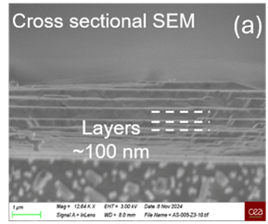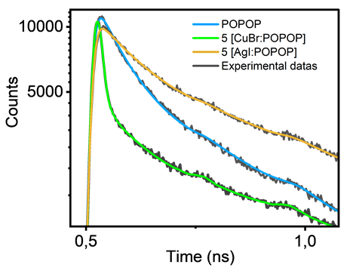
Figure 1. Left: SEM image of a meta scintillators, Right ultrafast TSCPC of meta scintillator devices and control showing decay time down to 16 ps.
- Y. Kurman, N. Lahav, R. Schuetz, A. Shultzman, C. Roques-Carmes, A. Lifshits, S. Zaken, T. Lenkiewicz, R. Strassberg, O. Be’er, Y. Bekenstein, and I. Kaminer, Sci. Adv. 2024, 10, eadq6325
- Y. Kurman, A. Shultzman, O. Segal, A. Pick, I. Kaminer, Phys. Rev. Lett. 2020, 125, 040801.
- E.M. Purcell, Phys. Rev. 1946, 69, 681.
- A. A. Seddon, J-F. Audibert, I. Leray, J. Leroy, L. Tortech, A. Erroi, I. Villa, A. Monguzzi, G.H. V. Bertrand, under review

We would like to acknowledge A.S. LALLEMAND and the PTC-ID program at CEA for funding

