Empirical Test of Gamma Emission Tomography to Inspect Partial-defect within PWR-type Spent Nuclear Fuel

Hyung-Joo Choi¹, Hee-Kyun Baek², Jung-ki Shin², Sung-Woo Kwak³, and Chul Hee Min¹

¹Department of Radiation Convergence Engineering, Yonsei University, Republic of Korea
²NeosisKorea Co. Ltd, Republic of Korea
³Korea Institute of Nuclear Nonproliferation And Control, Republic of Korea
Corresponding Author Email: chmin@yonsei.ac.kr

Spent Nuclear Fuel (SNF) is byproduct of nuclear power generation that not only emits significant amount of radiation but also contains a variety of nuclides. Among various SNF inspection techniques, Gamma Emission Tomography (GET) is reported as most reliable technique to detect the defects at pin-by-pin level since it can obtain cross-sectional image of SNF. In our previous study, we optimally designed scintillator-based GET instrument named Yonsei Single-photon Emission Computed Tomography (YSECT). The aim of this study is to experimentally evaluate the performance of YSECT instrument using the test water tank and the mock-up of SNF.
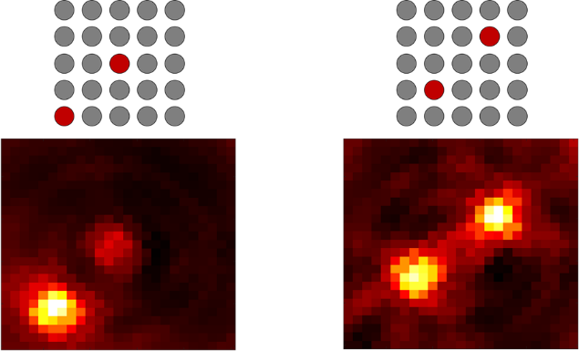
YSECT instrument was composed of four detection modules, and each detection module was consisted of tungsten collimator, 46-channel trapezoidal GAGG scintillators, and silicon multiplier. The mock-up of SNF, lead dummy pin, and test water tank were manufactured to mimic the actual SNF inspection condition. To evaluate the performance of YSECT instrument, the projection and tomographic images were acquired underwater. The sources and lead dummy pins were placed in accordance with the specifications of Westinghouse 14$×$14-type SNF.
Fig. 1. The tomographic images obtained underwater using the lead dummy pin and the mock-up of SNF.
Before evaluating the performance of the YSECT instrument, projection images obtained in air and underwater was conducted to assess the degree of image quality degradation. The noise level was increased by a factor of 1.7, and spatial resolution was deteriorated from 9.3 mm to 12.4 mm. Since the nuclear fuel rods of WH 14$×$14-type SNF were arranged at 14.12 mm intervals, the SNF visualization capability was validated underwater. The source distribution was clearly distinguished (Fig. 1.); however, the pixel intensity of inner layer was exponentially decreased due to water and lead dummy pin. Nevertheless, the source distribution can be confirmed through direct visual observation.
In current study, the performance of YSECT instrument was experimentally evaluated under mimicked actual SNF inspection condition. Based on the results, we believe that the developed GET instrument can be effectively employed to inspection partial-defect within the PWR-type SNF.

1. HONKAMAA, Tapani, et al. A prototype for passive gamma emission tomography. In: Proc. Symp. Int, Safeguards. 2014.

This work was supported by the Nuclear Safety Research Program through the Korea Foundation Of Nuclear Safety (KoFONS) using financial resources granted by the Nuclear Safety and Security Commission (NSSC) of the Republic of Korea (RS-2021-KN050310), and the Basic Science Research Program through the National Research Foundation of Korea (NRF) funded by the Ministry of Education (RS-2024-00412203).

