The Upgrade of the LHCb Electromagnetic Calorimeter:
Light-based Technologies with Picosecond Timing

Loris Martinazzoli¹
On behalf of the LHCb ECAL Upgrade II R&D group
¹European Organization for the Nuclear Research (CERN), Geneva, Switzerland
Corresponding Author Email: loris.martinazzoli@cern.ch

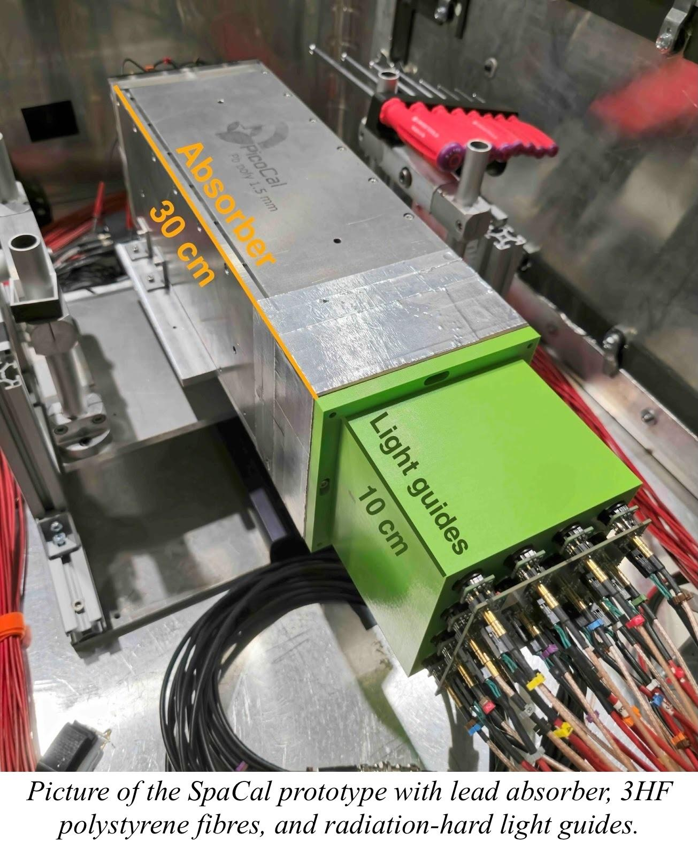
The aim of the Upgrade II of the LHCb detector is to operate during Run 5 of the CERN Large Hadron Collider (LHC) at a luminosity of
1 x 10³⁴ cm⁻² s⁻¹ to collect a data set of 300 fb⁻¹. The increase in particle densities requires a substantial modification of the present Electromagnetic Calorimeter (ECAL). The modules of the new calorimeter, the PicoCal, must feature radiation-hard technologies and timing capabilities down to tens of picoseconds [1]. Spaghetti calorimeter (SpaCal) and Shashlik technologies will be used for the upgrade. Moreover, an enhancement is planned already during the LS3 of the LHC, to cope with ageing effects of the present modules [2].

The design of the new modules includes both organic and inorganic scintillators: the region facing up to 1 MGy of radiation dose will be equipped with crystal garnet fibres, whereas the region up to 200 kGy with organic scintillators. An intense R&D campaign is ongoing to identify and optimize the material compositions. That includes accelerating the scintillation of the garnets to cope with the high particle rate and developing radiation-tolerant plastics, for instance with red organic dyes or nanomaterials.

Several calorimeter prototypes with cast lead and 3D-printed tungsten absorbers were produced and tested, comparing different scintillators, studying optical couplings, and testing multiple readout configurations with fast photodetectors. The obtained energy resolutions showed sampling and constant terms of about 10% / sqrt(E) and 1%, respectively, while the time resolutions reached 15 ps [2, 3]. The results are in agreement with detailed Monte Carlo simulations.

While the prototypes reach the target performance, further development and optimisation of the scintillating materials is necessary. This contribution gives an overview of the project, presenting the latest experimental results of the SpaCal and Shashlik prototypes and focusing on the ongoing R&D on organic and inorganic scintillators.

- The LHCb Collaboration, LHCb Upgrade II Scoping Document, 2024, LHCB-TDR-026, http://dx.doi.org/10.17181/CERN.2RXP.HDK0
- The LHCb Collaboration, LHCb Particle Identification Enhancement Technical Design Report, 2023, http://dx.doi.org/10.17181/CERN.LAZM.F5OH
- An L. et al., Performance of a spaghetti calorimeter prototype with tungsten absorber and garnet crystal fibres, NIM A, 2023, 1045, 167629, https://doi.org/10.1016/j.nima.2022.167629

